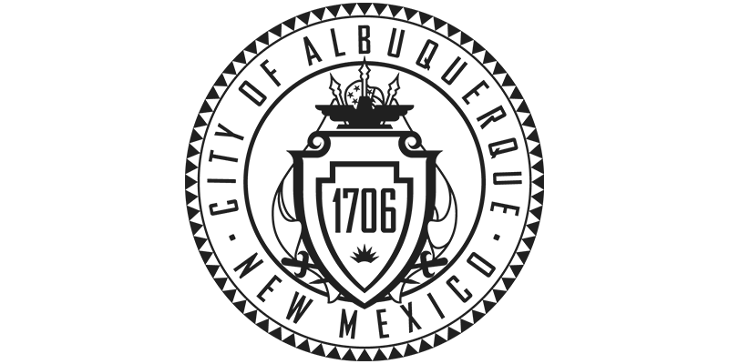City of Albuquerque Property Fact Sheet

Property ID: 100905637009142522
Legal Description: THE S'LY PORTION OF TR 433 TOWN OF ATRISCO GRANT UNIT # 3 CONT .4879 AC
Address: San Ygnacio Rd SW, Albuquerque, New Mexico 87121
Acreage: .487ac.

Property ID: 100905635508942523
Legal Description: S'LY 280 FT OF TR 434 TOWN OF ATRISCO GRANT UNIT #3 CONT 1.3100 AC
Address: San Ygnacio Rd SW, Albuquerque, New Mexico 87121
Acreage: 1.31ac.

Zoning: PD
